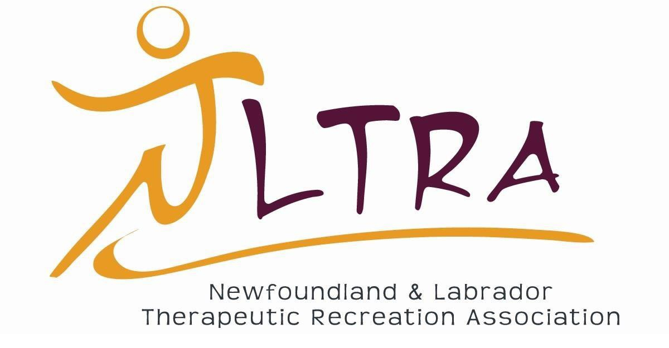

Annual Conference and AGM Thursday October 15th & 16th, 2020

Virtually via Zoom

Schedule: Preconference 3
Session Descriptions: Preconference
Anne-Marie Sullivan 4
Speed Mentoring 5 - 6
Schedule: Conference & Annual General Meeting 7
Bev Foster 8
Kathleen Colonello 9
Wayne Miller 10
Rosemary Moritz 11
Anne-Marie Sullivan 12
Annual General Meeting 13 - 15
2019-2020 NLTRA Executive 15 - 19
NLTRA Executive: Positions for Election 20 - 21
Awards 22- 24
Education Opportunities 25
Miscellaneous 26 - 27

Pre Conference Thursday, October 15th, 2020
Virtually via Zoom
Join Zoom Meeting https://zoom.us/j/93822361342
Meeting ID: 938 2236 1342

Time | Session Information
1:00pm – 1:15pm | Login, Setup and Troubleshooting
1:20pm – 1:35pm | Jonathan Barrow NLTRA President  Welcome and Opening Remarks
1:40pm – 2:40pm | Dr. Anne-Marie Sullivan  Experiential Learning and the TR Intern
2:40pm – 2:55pm | Break
3:00pm – 4:00pm | Speed Mentoring: Learning from Our Peers
4:10pm – 4:30pm | Jonathan Barrow NLTRA President  Closing Remarks

Session Title: Experiential Learning and the TR Intern

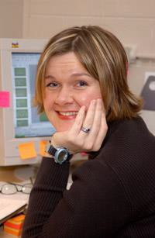
Presenter: Dr. Anne-Marie Sullivan

Dr. Sullivan is the current Associate Dean with the School of Human Kinetics & Recreation at Memorial University. She is the primary instructor for TR courses in the Recreation program and is the academic supervisor for all interns. Presently she is researching the role of the internship in student preparedness.

Session Description

This session will focus on experiential learning as part of TR student preparedness. The internship is meant to be an extension of classroom learning but this research suggests that students are not making the connections they should be between theory and practice. This engagement requires the commitment of the academic supervisor, the clinical supervisor and the student to happen in a meaningful way. Educators, practitioners and students will all benefit from better understanding the anticipated outcomes associated with the NCTRC internship. We will review the competencies and discuss strategies to meet these competencies.

Learning Outcomes

- Participants will gain knowledge about experiential learning
- Participants will be able to identify at least three strategies to provide positive internship experience
- Participants will gain knowledge of the role of the internship in TR preparation

Session Title: Speed Mentoring: Learning from Our Peers

Mentors: Carl Ings, Ashley Mercer, Paul Hanrahan, Elise Fisher and Donna Sheppard

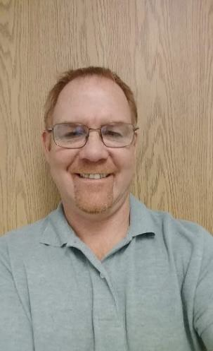
Carl Ings, Certified Therapeutic Recreation Specialist (CTRS) Recreation Development Specialist
Mental Health and Addictions (2E Adult Psychiatry 20 Bed Unit & Hope Valley Youth Treatment Center 12 Bed Unit)
Adults and Youth with Mental Health and Addictions Central Health
21 years’ experience in the field of Therapeutic Recreation Bachelor of Recreation from Dalhousie University

Ashley Moore, Certified Therapeutic Recreation Specialist (CTRS) Recreation Development Specialist II (Clinical Lead)
Janeway Rehab and Development Pediatrics
Eastern Health
10 years’ experience in the field of Therapeutic Recreation
Bachelor of Recreation from Memorial University of Newfoundland

Paul Hanrahan
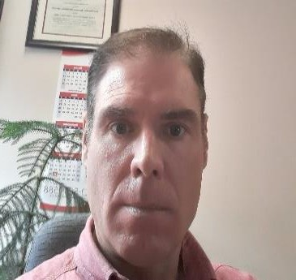
Recreation Development Specialist II (Clinical Lead) Adult Rehab/Continuing Care
Dr. Leonard A. Miller Centre (LAMC)
Stroke, Spinal Cord and other neurologist’s conditions. Eastern Health
28 years’ experience in the field of Therapeutic Recreation Bachelor degree in Recreation from Acadia University

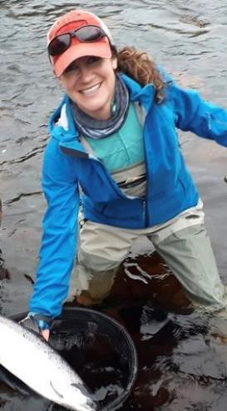
Elise Fisher
Recreation Therapy Worker II
Still Waters, Western Long-term Care Home (Geriatrics) Western Health
7+ experience in the field of Therapeutic Recreation

Donna Sheppard
Recreation Development Specialist Bay St George Long Term Care Centre Geriatrics
Western Health
17 years’ experience working in the field of Therapeutic Recreation
Bachelor degree in Recreation and Leisure Studies, Specialty in Recreation Therapy and a minor in Gerontology

Session Description

In this session, delegates will have the opportunity to meet individuals currently working in the field of Therapeutic Recreation. These individuals will mentor participants for a brief period of time (10 -15 mins). During this time the mentors will discuss the five W’s(Who, What, Where, When and Why) of their work, as well as open the floor for a question and answer period as well as an opportunity to share amongst the members of the “room”. Participants will be given the opportunity to have follow up discussions with the mentors if they wish and have the opportunity to expand their network of peers within the circle of Therapeutic Recreation.

Learning Outcomes

- Participants will have the opportunity to have open discussions on topics related to the field of TR that can yield answers or suggestions for them to use in their own practice and career path.
- Participants will gain a better understanding of what TR looks like in a variety of practice areas.
- Participants will have the opportunity to meet mentors and make connections with individuals in the field of TR.

Conference & Annual General Meeting Friday, October 16th, 2020
Virtually via Zoom

Join Zoom Meeting https://zoom.us/j/92702139604 Meeting ID: 927 0213 9604
Time | Zoom  *link to login will be sent to registered delegates 1 week prior to the conference
8:30am - 8:45am | Login, Setup & Troubleshooting
8:45am – 8:55am | Jonathan Barrow NLTRA President  Welcome and Opening Remarks
9:00am – 10:00am | Bev Foster  Using Participatory Action Design to Develop an Integrated Music Program to Reduce Isolation and Loneliness in Long-term Care
10:00am – 10:15am | BREAK
10:20am – 11:05am | Kathleen Colonello  Discussion on Adaptive Yoga in Senior Care
11:05am-11:15am | BREAK
11:15am – 12:30pm | NLTRA Annual General Meeting
12:30pm – 1:00pm | LUNCH BREAK
1:05pm – 1:45pm | Wayne Miller  Why is Therapeutic Recreation so Important in Patient Safety
1:45pm – 2:00pm | BREAK
2:05pm – 3:05pm | Rosemary Moritz  Promoting Healthy Aging through Creative Based Activities
3:15pm – 4:15pm | Dr. Anne-Marie Sullivan  Scope of Practice for Therapeutic Recreation in Newfoundland and Labrador
4:15pm – 4:30pm | Jonathan Barrow NLTRA President  Closing Remarks

Session Title: Using Participatory Action Design to Develop an Integrated Music Program to Reduce Isolation and Loneliness in
Long-term Care

Presenter: Bev Foster, MA, Bed, BMus, ARCT, AMus

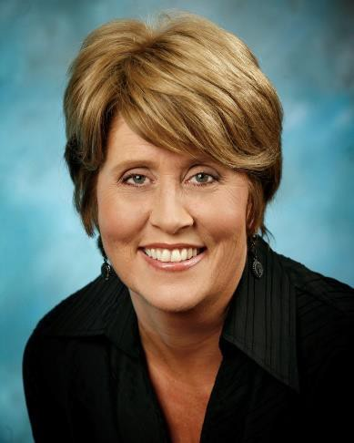
Bev Foster is the Founder and Executive Director of the Room 217 Foundation, a health arts organization dedicated to music and care. She is an experienced musician who speaks and writes extensively on the power of music, especially in life limiting situations. Her passion for music enhancing quality of life is contagious. She has presented this topic for a number of organizations including at the Canadian Hospice Palliative Care conference, Hospice Palliative Care Ontario and Manitoba HPC Conference workshops, New Brunswick and BC Palliative Care conferences, as well as at the International Association of Music Medicine Conference 2020

Session Description

The music care approach expects that music care delivery is informed by the best available information. One of the most well-suited methodologies for understanding the effects of music care is participatory action design because the delivery of music care considers community-centered factors. This session will explore an adapted action research methodology that operationalized the integrated model of music care in a study in 24 long-term care homes in the Greater Toronto Area to reduce the experience of resident isolation and loneliness!

Learning Outcomes

- Summarize rationale for using action research
- Recognize the steps of participatory action research
- Describe the integrated model of music care
- Explain the music care approach

Session Title: Discussion on Adaptive Yoga in Senior Care

Presenter: Kathleen Colonello

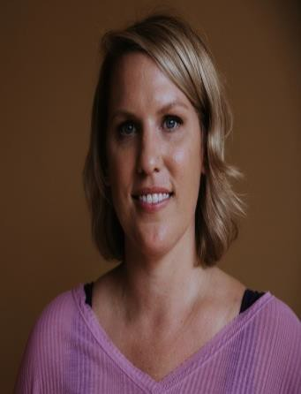
Kathleen is an experienced registered yoga teacher (eRYT200), Yoga Alliance continuing education provider (YACEP), and Life Enrichment Manager at an Assisted Living facility in Michigan. Her bachelor’s degree is from Oakland University with a focus in Wellness, Health Promotion, and Injury Prevention. She have been a caregiver to her mother since 2003, a Life Enrichment Director since 2012, and co-runs an Alzheimer’s support group with the Alzheimer's Association. She has taught daily chair yoga classes for special populations for over 8 years.

Session Description

Join Kathleen Colonello as she discusses the many benefits of Adaptive Yoga for special populations including seniors, persons with dementia and other physical limitations.

Learning Outcomes

- Learn best practices in communication during an adaptive yoga class.
- Learn how to use music properly during a chair yoga class.
- Learn a few basic chair yoga poses.

- In partnership with the NLTRA, Kathleen will be offering a Virtual Chair Yoga Teacher Training in February 2020. Details coming soon.

Session Title: Why and How can Therapeutic Recreation be an Important Advocate for Patient Safety.

Presenter: Wayne Miller

Wayne is a Senior Program Manager with the Canadian Patient Safety Institute(CPSI) since 2012. He has over 30 years of experience in healthcare, has a Master of Healthcare Administration from University of Colorado and is a Fellow of the Canadian Foundation for Healthcare Improvement’s EXTRA program. Prior to joining CPSI, he provided leadership in clinical services, executive administration, and research at both a hospital and regional health authority. He current leads initiatives on Measurement and Monitoring of Safety, Knowledge to Action Framework, research and patient safety and Indigenous people and communities.

Session Description

This session will present a new conceptual approach to patient safety and discuss how Therapeutic Recreation staff can champion this approach. The Canadian Patient Safety Institute (CPSI) has run two national learning collaboratives introducing the concepts of a new approach to patient safety. This progressive approach can help Therapeutic Recreation staff understand and discuss the risks associated with their profession while providing a common view of safety.

Learning Outcomes

- Participants will develop a broader understanding of safety.
- Participants will develop greater knowledge of how the presence of safety is different from the absence of harm.
- Participants will be able to discuss how knowledge of reliability, situational awareness, psychological safety, simulation and integrated learning can assist their patients, strengthen their Therapeutic Recreation team, and build a stronger link to the multidisciplinary team.
- Participants will gain a greater perspective of how this expanded view can assist Therapeutic Recreation practitioners in advocating for their profession.

Session Title: Promoting Healthy Aging through Creative Based Activities

Presenter: Rosemary Moritz

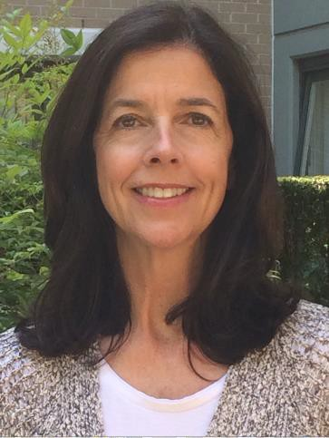
After graduating from the University of Southern California, Rosemary was drawn to the field of acting and discovered a passion for theatre games- a fun, interactive ad-lib experience for groups. Rosemary realized the potential of utilizing theatre game exercises as an effective tool for social connection and self-expression for non-actors when she taught theatre games to troubled youth in Hollywood, CA. Soon afterwards, she came across a pivotal study on Arts Intervention for Older Adults by Tony and Helga Noice, Elmhurst College. The study stated that acting is one of the best activities for improving and maintaining cognitive health in older adults. After further research, Rosemary found many studies supporting the theory that creative activities are beneficial for brain health, social interaction and quality of life. This inspired Rosemary
to further develop the program that she had started in Los Angeles and Perk Activities was the result, a weekly program to mentally stimulate and socially connect seniors. Over the last 12 years, the program has been a popular feature in numerous retirement and senior communities.

Session Description

By 2030, seniors will number over 9.5 million, making up 23% of the Canadian population with the population of people 85+ continuing to increase. Research is showing that the creative arts are one of the most effective, cost-efficient and powerful tools for healthy aging. We will look at what healthy aging means, why the creative arts are important especially for seniors to age well and introduce you to Perk Activities, programs that promote healthy aging.

Learning Outcomes

- Aging: from seniors perspective and strategies for healthy aging
- Creative Arts: a powerful tool for healthy aging
- Perk Activities: a holistic, creative program for healthy aging

Session Title: Scope of Practice for Therapeutic Recreation in Newfoundland and Labrador

Presenter: Dr. Anne-Marie Sullivan

Dr. Sullivan is the current Associate Dean with the School of Human Kinetics & Recreation at Memorial University. She is the primary instructor for TR courses in the Recreation program and is the academic supervisor for all interns. Presently she is researching the role of the internship in student preparedness.

Session Description

This session will examine the current status of TR in NL and provide context for advancing the discipline in NL. We will consider current service delivery and propose needed changes to practice to better serve the residents of NL. TR services in other provinces will be shared and gaps in service in NL will be identified.

Learning Outcomes

- Participants will gain knowledge about TR in other provinces
- Participants will be able to identify at least three areas of services for future development
- Participants will gain knowledge of the role of TR on interprofessional teams in at least three program areas.

Annual General Meeting (AGM)
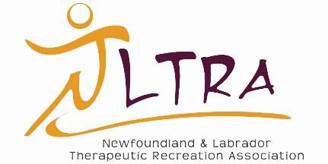

Newfoundland and Labrador Therapeutic Recreation Association

1.0 Call to Order

Annual General Meeting (AGM) October 16th, 2020

2.0 Introduction of the 2019-2020 Board of Directors
3.0 Acceptance of the Agenda
4.0 Acceptance of NLTRA 2019 AGM Minutes
  - Business Arising
  - Website

  - Reports
  - Board update
  - Membership Status
  - Financial Statement
  - Sub-committee Updates

  - Election of Officers
  - President Elect
  - Central VP
  - Student VP
  - Membership Coordinator
  - Education and Conference Coordinator
  - Secretary
  - Treasurer
8.0 Sub-committees
9.0 Thank You’s
10.0 Awards

11.0 Adjournment

Annual General Meeting (AGM) Continued NLTRA 2019 AGM Agenda Minutes

NLTRA AGM October 18, 2019
Meeting called to order: 12:11 pm

Board of Directors:
Pres. Gillian Redmond
Pres Elect: Jonathan Barrow East VPN: Tara Power West VPN: Elise Fisher
Student VPN: Cara Berglund Treasurer: Charlene Edwards Membership: Erica Egedy
Website Coordinator: Ann Marie Kelley Conference Coordinator: Catherine Tee

4.1 New Business
New board positions: Conference coordinator and website coordinator Move to change website coordinator to a professional board position No discussion/questions. Approved

  - Board Updates:
Gillian provided an update. See board reports compiled and sent to Jonathan, Gillian and Catherine on Oct 17, 2019 by Airdrie Miller. Thank you to all members who sent reports.

  - Membership status Erica Egedy. 48 student members and 34 professional members. Total numbers just over 100.

  - Financial update Charlene Edwards

  - Sub Committee Updates available on the NLTRA website.

  - President Elect:
Nominated: Erica Egedy-accepted Catherine Tee-declined Erica Egedy successful

  - Eastern VP:
Nominated: Charlene Edwards successful

6,3 Western VP:
Nominated: Elise Fisher successful

  - Student VP:
Nominated: Kyle Parsons, Robyn Grouchy, Kristina LeDrew, Jeff Anderson All accepted nomination.
Robyn Grouchy successful

  - Website Coordinator
Nominated: Gillian Redmond, Cara Berglund Both accepted nomination
Gillian successful

  - Membership Coordinator Nominated: Tara Power, Krista Doyle
Tara accepted nomination, Krista declined. Tara successful

  - Treasurer
Nominated: Cara Berglund Cara successful

7.1 Sub-Committees
Conference Planning, Advocacy Regulation, Evidence-Based Practice All sub-Committee members were recognized and thanked.
Thank you to student attendees from Academy Canada, MUN and CNA and presenters.

8.1 Awards:
Professional of the Year: Kyle Smook RTW II Buchans Outstanding Student of the Year: Omobosola Lasisi
Leadership in Therapeutic Recreation of the Year: Joanne Bennett Meeting Adjourned at 1:05
Minutes taken by Secretary, Airdrie Miller

2019-2020 NLTRA Executive
The NLTRA Executive is made up of therapeutic recreation professionals, students and supporting members who work tirelessly throughout the year towards achieving the goals and objectives outlined in the NLTRA’s Strategic Plan for that year. The executive is made up of the following positions and filled by the following individuals;

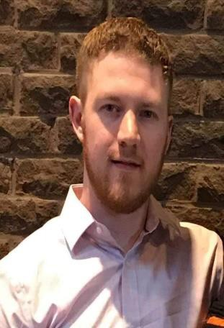
President
Jonathan Barrow, Certified Therapeutic Recreation Specialist, Eastern Health

Jonathan is currently employed as a Recreation Development Specialist with Eastern Health. Jonathan graduated from Memorial University with a Bachelor’s degree in Recreation and is certified through the National Council of Therapeutic Recreation (NCTRC) as a Certified Therapeutic Recreation Specialist (CTRS). Jonathan has served in various capacities on the NLTRA Board of Directors including; Eastern VP and President-Elect.

President Elect
Erica Egedy, Certified Therapeutic Recreation Specialist, Central Health

Erica is the Recreation Development Specialist at the Dr. Hugh Towmey Centre in Botwood. She has worked at the Towmey Centre for 7 years. She started as a Recreation Therapy Worker II but has been in the Recreation Specialist role for the past year and a half. She enjoys playing volleyball, walking and watching her son play hockey. Besides volunteering with the NLTRA she is also the team manager for her sons hockey team and she has been the Chair for School Council, for the past 3 years. She enjoys her volunteer positions very much as it is a great way for her to stay
connected within the community. Over the years, Erica has held a number of positions with the NLTRA which include; Central VP, Membership Coordinator and now President Elect, she will be moving into the President position for the coming year. She is looking forward to working hard to advocate for TR within the province and with the support of the NLTRA membership she is sure together everyone will be able to do great things.

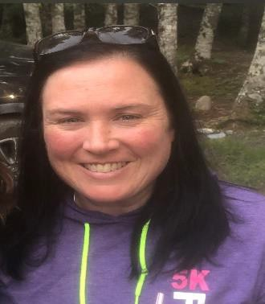
Eastern Vice President
Charlene Edwards, Certified Therapeutic Recreation Specialist, Eastern Health

Charlene Edwards is a CTRS with a Specialization in Geriatrics from NCTRC. She has been working in Therapeutic Recreation for over 20 years holding positions in Ontario and Alberta before returning home to Newfoundland in 2007. Charlene has been on the NLTRA Board of Directors in several different positions from membership coordinator, treasurer and Eastern VP. She is currently working as a CTRS on the Geriatric Assessment Unit at the Waterford Hospital. Charlene holds
the education of diploma in Community Recreation Leadership from College of the North Atlantic, post graduate diploma in Therapeutic Recreation from Georgian College and Bachelor of Arts in Recreation from Memorial University. Charlene has a passion for working with the Geriatric population as well as advocating and supporting the profession of Therapeutic Recreation. In her down time Charlene is a busy mom of two teenage girls and a dog mom to a very busy 12 month old Golden Retriever as well spending time with family and friends.

Central Vice President
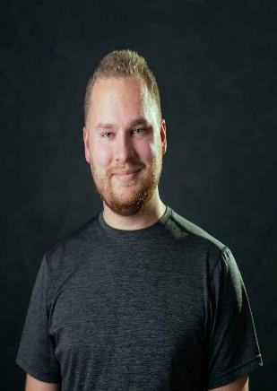
Kyle Smook, Recreation Therapy Worker, Central Health

Kyle is a Recreation Therapy Worker with Central Health in Buchans. Kyle received his Diploma in Therapeutic Recreation from Academy Canada in 2016 and is currently working towards his Bachelor of Therapeutic Recreation degree through distance education from the University of Lethbridge. Kyle has been a member of the NLTRA Board of Directors since 2018. He also co-chairs the Education & Conference Subcommittee. His work on navigating the online platform Zoom for this year’s conference has been instrumental!

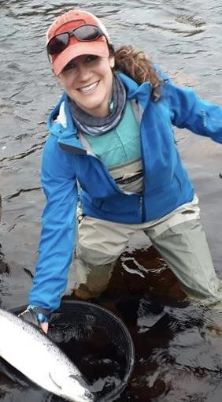
Western Vice president
Elise Fisher, Recreation Therapy Worker, Western Health

Elise is a Recreation Therapy Worker at the new Western Long Term Care facility in Corner Brook. She has been with Western Health for 7 years, in geriatric settings.
Elise is originally from Nova Scotia, but she and her husband have found a beautiful home on this province’s west coast that provides awesome opportunities for skiing, hiking, canoeing, and salmon fishing! Elise has been a member of the NLTRA Board of Directors for many years, serving in positions including Student VP and on various subcommittees.

Membership Coordinator
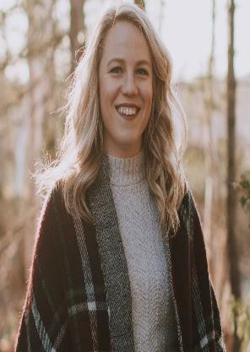
Tara Power, Certified Therapeutic Recreation Specialist, Eastern Health

Tara is a Recreation Development Specialist with Eastern Health in St. Johns, NL. She works at the Waterford Hospital; the mental health and addictions hospital on an acute care unit. Since graduating from Memorial University in 2012 with a Bachelors of Art in Recreation and obtaining her CTRS status from the National Council for Therapeutic Recreation Certification she has worked in various mental health and addiction and pediatric programs. She is currently serving her 5th term on the NLTRA as a board member and has sat on numerous committees including internship, education, and CTRS committees. During her free time Tara enjoys running, yoga, and spending time outdoors with family and friends.

Education & Conference Coordinator
Catherine Tee, Certified Therapeutic Recreation Specialist, Eastern Health

Catherine currently works as a Recreation Development Specialist at the long-term care facility, Private Josiah Squibb Memorial Pavilion (PJSMP) in Carbonear. She completed her Diploma of Arts in Community Recreation Leadership at the College of the North Atlantic in 2012 and obtained her Bachelors of Recreation with a concentration in Therapeutic Recreation from Memorial University of Newfoundland in 2015. She has been a Certified Therapeutic Recreation Specialist through the National Council for Therapeutic Recreation Certification (NCTRC) since 2015. In her free time Catherine enjoys camping, reading, exercising and cuddling with her cat, Baby Sadie. Catherine has been a volunteer with various NLTRA subcommittees and has served on the NLTRA Board of Directors in the Education & Conference Coordinator role since 2018.

Secretary
Airdrie Miller, Certified Therapeutic Recreation Specialist, Eastern Health

Airdrie Miller is a CTRS with 30 years’ experience who has presented at both the NLTRA and CTRA Conferences. Airdrie has been active with the NLTRA for many years volunteering on subcommittees and in roles such as She has worked with
clients in mental health and addictions, rehabilitation, and is currently practicing in pediatrics with the Janeway Lifestyles Program. Her education includes a Bachelor of Physical Education, Bachelor of Education and a Certificate in Life Skills Instructor Training. Airdrie enjoys family activities and anything outdoors, especially skiing, biking and swimming.

Treasurer
Cara Berglund, Certified Therapeutic Recreation Specialist, Eastern Health

Cara has been working with Eastern Health since 2018 and currently works as a Recreation Development Specialist at the S.A. Glenbrook Lodge. In her spare time, she enjoys hiking, hunting, fishing, swimming, and anything else to do with the outdoors. She also enjoys a game of crib or 120s, painting on canvases, and telling people jokes or riddles. In the past Cara has served on the NLTRA Board of Directors in the position of Student VP.

Student Vice President
Robyn Grouchy, Academy Canada Therapeutic Recreation Student

Robyn is a mother to an outgoing and ambitious 10 year old daughter. She is currently Therapeutic Recreation at Academy Canada with plans to study at Lethbridge University next fall to become a Certified Therapeutic Recreation Specialist. She has a strong passion for the field of Therapeutic Recreation and believes in the importance of advocating for Therapeutic Recreation, Mental Health, inclusion and diversity. Once completed her academic pursuits, she hopes to work in the St. John's metro area to
provide quality, purpose driven programming, to the most vulnerable populations. She is a certified instructor and coach and has been the recipient of multiple leadership awards, instructor of the year award, and most enthusiastic. She cannot wait to begin her career as a Recreational Therapist. Robyn has served on the NLTRA Board of Directors in the Student VP role since 2019.

Website Coordinator
Gillian Redmond, Certified Therapeutic Recreation Specialist, Eastern Health

Gillian currently works as a Recreation Development Specialist in the Mental Health and Addictions program in Eastern Health. Gillian has served on the NLTRA Board of Directors in various capacities, including President-Elect and President.

Picture Unavailable

NLTRA Executive: Positions for Election
The following positions are up for election at this year’s Conference and AGM on October 16th, 2020:

President Elect Central Vice President
Membership Coordinator

Education & Conference Coordinator Secretary
Treasurer

Student Vice President

Nominees must be a member in good standing of the NLTRA.
Nominations can be emailed to the NLTRA Secretary at nltrageneralenquiries@gmail.com
No later than Wednesday, October 14th, 2020 4:00pm .
Nominations will also be taken from the “floor” during the AGM on Friday, October 16th, 2020.

Position descriptions and nomination information on the next page.

NLTRA Executive: Positions for Election Continued

President Elect - The president elect shall serve for a two-year term. The first of this position would be as president elect. This position would assume the role of president for the second year of this position. The president-elect must be a current board member for at least one year.

Central Vice President - The vice-presidents shall serve for a two-year term and shall chair the regional chapters of the Corporation and shall perform the duties assigned by the president. The vice-presidents shall submit a monthly report outlining activities in their region as well as any activities relevant to the corporation.

Membership Coordinator - The membership coordinator shall serve for a two-year term and shall process all registration applications including notice for renewal and distribution of membership numbers. The membership coordinator shall perform any other membership duties assigned by the president.

Education & Conference Coordinator - The conference coordinator shall serve for a two- year term and will organize the annual conference in collaboration with the NLTRA Board. The conference coordinator shall establish a conference planning committee and will chair conference planning meetings. The conference coordinator will also make a minimum of 3 webinars available to members annually.

Secretary - The secretary shall serve a two-year term and shall keep accurate records of all meetings of the Corporation and the board of directors and perform other duties assigned by the president.

Treasurer - The treasurer shall receive the monies of the Corporation and shall pay all expenses of the Corporation in the manner set down by the board of directors. The treasurer shall keep an accurate record of all receipts and expenditures and shall present an up-to-date statement of accounts to the annual general meeting of members and when requested to do so by the board of directors.

Student Vice President - The student vice president shall serve for a one-year term and must be a student for at least half of this duration. The student vice president shall establish communication across all post-secondary institutions that offer therapeutic recreation. The student vice president shall manage all social media accounts associated with NLTRA in collaboration with the NLTRA Board and perform other duties assigned by the president.

Awards

The Newfoundland and Labrador Therapeutic Recreation Association Awards Program recognizes the contributions of individuals/groups to the field of Therapeutic Recreation. These awards will celebrate and acknowledge the achievements of those making a difference in the field of Therapeutic Recreation within Newfoundland and Labrador. Please note that in order to be eligible for the award, the nominee must be a member of the Newfoundland and Labrador Therapeutic Recreation Association.

AWARD CATEGORIES
Professional/Recreation Therapy Team of the Year Award Outstanding Student of the Year Award
Leadership Award in Therapeutic Recreation

AWARD NOMINATION PROCESS
Complete the Nomination Form and send to NLTRA Secretary at nltrageneralenquiries@gmail.com

Professional/Recreation Therapy Team of the Year Award

Criteria Guidelines:
- Nominee must be a professional member or at least half of Recreation Therapy Team must be members in good standing for 1 year minimum.
- Exhibit dedication to providing quality Therapeutic Recreation service to population health through continuing education, development and sharing of evidence-based practice and programming, or quality improvement initiatives.
- Commitment to continuing education opportunities through attendance to conferences, workshops, courses, development/attendance of presentations, and/or research in the field of Therapeutic Recreation.
- Exceptional advocate of the field of Therapeutic Recreation, professional practice, ethics, within and/or outside practice area.

Award:
Certificate and Plaque

Outstanding Student of the Year Award

Criteria Guidelines:
- Nominee must be a student member in good standing with membership with NLTRA for 1 year minimum
- Employed full-time or part-time in an accredited university/college
- Has undertaken an independent challenge or an academic project that encompasses initiative, innovation and demonstrates the ability to implement a program or project within the population or community base of interest.
- Nominee must have volunteer/work experience in Therapeutic Recreation.

Award:
Certificate and Plaque

Leadership Award in Therapeutic Recreation (Individual or Group)

Criteria Guidelines:
- Nominee(s) must be a member in good standing with membership with NLTRA for 1 year minimum
- Made a significant contribution to the field of Therapeutic Recreation which may include service on committees and boards which represent advancement in our field, outstanding resident/client/patient care, advocacy work in the field of Therapeutic Recreation, and/or the development of workshops/presentations promoting Therapeutic Recreation across the province of Newfoundland and Labrador and/or Canada.
- Has undertaken projects that encompass initiative and innovation that contributes to Therapeutic Recreation practice and quality client care in their population of interest and/or employment.
- Nominee must be committed to ongoing involvement in advancing personal and professional knowledge related to Therapeutic Recreation.
- Nominee should represent professionalism, quality, positivity, motivation, and an innate passion for the field of Therapeutic Recreation.

Award:
Certificate and Plaque

NLTRA Awards Nomination Form
Instructions: Complete nomination form below and email form to nltrageneralenquiries@gmail.com
Award
- Professional/Recreation Therapy Team of the Year Award
- Outstanding Student of the Year Award
- Leadership Award in Therapeutic Recreation
Nominator Information
Name: NLTRA Membership #: Phone: Email: Nominee(s) Information
Name: NLTRA Membership #: Phone: Email: Name: NLTRA Membership #: Phone: Email:
Nominee(s) background, experience, achievements, and why this candidate should receive the
award. (500 words or less)

Education& Networking Opportunities
*all sessions will be provided using Zoom, unless specifically specified Register by emailing Catherine Tee at catherine.tee@easternhealth.ca
November 2020
Date: November 16 – 20, 2020
Benefits of Community/Recreational Drumming
Tom Alteen, Musubi Drum Circles
*YouTube link to be emailed to registered participants and available for viewing the week of Nov 16-20

January 2021
The Education & Conference Sub Committee are continuously working to provide our members with education, networking and other learning opportunities. If you have a suggestion or something that you would like to see an education session on please contact:
Education & Conference Coordinator Catherine Tee
catherine.tee@easternhealth.ca
(709) 945-6206
Date: Wednesday, January 20
Time: 9:30-10:30am or 3:00-4:00pm
Using Music Confidently in Palliative and End-of-Life Care
Bev Foster, Room 217 Care through Music

February 2021 Therapeutic Recreation Month
Date: February 22-26, 2020 Time: 2:00-4:30pm
Chair Yoga Teacher Training
Kathleen Colonello, Yoga Teacher

March 2021

Student Presentation Series:
Date: TBD Time: TBD Meditation
Robyn Grouchy, Jami Ryan & Gillian Chapman ~ Academy Canada TR Students

April 2021 Date: TBD Time: TBD
Advocating for Change: How one Recreation Specialist Successfully Advocated for Increasing Therapeutic Recreation Services in Mental Health and Addictions at the Waterford Hospital Charlene Edwards, Certified Therapeutic Recreation Specialist
Mental Health and Addictions Waterford Hospital, Eastern Health

October 2021
October 14th & 15th, 2021
NLTRA Annual Conference and Annual General Meeting

Miscellaneous
Instructions for Zoom:

Getting started with Zoom
Where do I download the latest version of Zoom?
You can download the latest version of Zoom from our Download Center. Learn more about downloading Zoom.
How do I use Zoom on my PC or Mac?
After downloading Zoom, learn how to use the Zoom Desktop Client.
Do you need an account to use Zoom?
A Zoom account is not required if you are strictly joining Zoom Meetings as a participant. If someone invites you to their meeting, you can join as a participant without creating an account. Learn more about joining a Zoom meeting.
How do I signup for Zoom?
You can sign up for a free Zoom account at zoom.us/signup.
Weekly live trainings
Join us for a live training to learn the basics of Zoom and ask questions live.

Joining a meeting
How do I join a Zoom meeting?
You can join a meeting by clicking the meeting link or going to join.zoom.us and entering in the meeting ID. Learn more about joining a meeting.
How do I join computer/device audio?
On most devices, you can join computer/device audio by clicking Join Audio, Join with Computer Audio, or Audio to access the audio settings. Learn more about connecting your audio.
Do I have to have a webcam to join on Zoom?
While you are not required to have a webcam to join a Zoom Meeting or Webinar, you will not be able to transmit video of yourself. You will continue to be able to listen and speak during the meeting, share your screen, and view the webcam video of other participants.

Please note:
- Zoom meeting links will be emailed out approximately one week before Day 1 of the Conference (October 15, 2020)
- Sign onto Zoom 15-30 minutes early using the name and email address you registered for the conference with. This name and email address will be used to verify that you have registered and paid for the conference. You will then be
granted access to the “room” the session is taking place in.
- If there are additional people viewing the session with you please include their name in the chat box for attendance purposes
- All individuals will be muted upon entering the presentation, feel free to have your video on or off
- All questions for presenters should be typed in the Chat Box on Zoom and the moderator will ask these questions at the end.
- All sessions will be recorded and emailed to all participants 3-5 business days post conference for review/viewing

Questions or concerns please reach out to:

Kyle Smook | (709) 687-7556 | kyle.smook@centralhealth.nl.ca
Catherine Tee | (709) 764-4002 | catherine.tee@easternhealth.ca

