

**ANNUAL CONFERENCE**

**PROGRAM GUIDE**

*October 20th – 21st, 2016*



TABLE OF CONTENTS

|  |  |
| --- | --- |
| President’s Greetings | 2 |
| Schedule | 3 - 4 |
| Presenter Biographies & Session Descriptions | 5 - 19 |
| Keynote Speaker | 5 |
| Presentation #1 | 6 |
| Presentation #2 | 7 |
| Presentation #3 | 8 |
| Presentation #4 | 9 |
| Presentation #5 | 10 |
| Presentation #6 | 11 |
| Presentation #7 | 12 |
| Presentation #8 | 13 |
| Presentation #9 | 14 |
| Presentation #10 | 15 - 16 |
| Presentation #11 | 17 |
| Presentation #12 | 18 |
| Presentation #13 | 19 |
| 2015/2016 Executive Biographies | 20 - 24 |
| President | 20 |
| President Elect | 20 |
| Eastern VP | 21 |
| Central VP | 21 |
| Western VP | 22 |
| Secretary | 22 |
| Treasurer | 23 |
| Membership Coordinator | 23 |
| Website Support | 24 |
| Sponsors | 25 |

President’s Greetings

W

elcome delegates to the Annual NLTRA Conference and AGM: “The Power of Ideas: Making Everyone Connection Count”. This year’s theme embodies the importance of our ideas and how we connect them to our practice in making positive impacts on the clients we serve. It also empowers us to expand and add to our current Therapeutic Recreation practices to improve the quality of our services in providing up-to-date trends to the residents of Newfoundland and Labrador.

I hope we can provide you the opportunity in the next couple days to gain some new knowledge, network with other professionals across the province, and get re-energized going back to the workplace. We thank our members for your continued support, for without, there would be no NLTRA.

The field of Therapeutic Recreation is advancing and Newfoundland and Labrador refuses to be left in the dust!

Regards,

Cassandra McLean

NLTRA President 2015-2016

schedule: day 1

*Multipurpose Room (MPR) Boardroom (BR)*

**Thursday October 20th**

**8:00 am - 9:00 am** Registration

**9:00 am - 9:15 am** Opening Remarks/Welcome from Mr. Bernard Davis, Parliamentary Secretary

**9:15 am - 9:45 am** Ice Breaker Activity

**9:45 am - 10:45 am** Opening Keynote (MPR)

**10:45 am- - 11:00 am** ***Nutrition Break/Silent Auction***

**11:00 am– 12:00 am** 1) Cognitive Stimulation in Dementia Care: The Potential of the Intern to Contribute to TR Literature (MPR)

2) Recreation Newfoundland and Labrador: Inclusion Services (BR)

**12:00 pm - 2:15 pm** ***Lunch/Silent Auction/CTRA/AGM***

**2:15 pm - 3:15 pm** 3) Incorporating Mindfulness in Therapeutic Recreation Practice (MPR)

4) The Path to Professional Practice (BR)

**3:15 pm - 3:30 pm** ***Nutrition Break/Silent Auction***

**3:30 pm - 4:30 pm** 5) Recovering Beyond Fear: What TR Professionals Need to Know (MPR)

**4:30 pm** **Closing Remarks** (MPR)

schedule: day 2

**Friday October 21st**

**9:00 am - 9:15 am** Registration/Opening Remarks

**9:15 am - 10:15 am** 6) Incorporating Evidence into TR Practice: Building a Strong Foundation in TR Service Delivery(MPR)

7) Therapeutic Gardening: Wellness Through Gardening and Nature (BR)

**10:15 am -10:30 am*****Nutrition Break/Silent Auction***

**10:30 am - 11:30 am** 8) Research in Practice (MPR)

9) Art for the Heart: Using Creativity to Battle Depression (BR)

**11:30 am - 12:30 pm** 10) Making Your One to Ones Count (MPR)

11) Dementia and its Impact on Health Professionals (BR)

**12:30 pm - 1:30 pm  *Lunch/ New Executive Meeting (Board Room)***

**1:30 pm – 2:30 pm** 12) Looking at Leisure through an Occupational Therapy Lens (BR)

13) Making Every Connection Count: Engaging &  
Retaining Your Dream Volunteer (MPR)

**2:30 pm - 2:45 pm *Nutrition Break/Silent Auction***

**2:45 pm- 3:15 pm** **Closing by Keynote Speaker** (MPR)

**3:15 pm – 3:45 pm Closing Remarks/Silent Auction Wrap Up** (MPR)

keynote

**SESSION TITLE** ***What’s Your Staus?***

**PRESENTER** Vahen King

**Vahen King** is a graduate of Theological Studies from Masters College & Seminary, Credentialed Licensed Minister with the PAOC, and Certified Life Coach.

Vahen feels that because of her own emotional, physical, and spiritual battles, God has enabled her to help anyone who has felt fearful, unworthy, or unloved. She feels the message she has to share, will challenge people`s self-doubt and empower them to "Go Farther."

Vahen believes that all the events in her life—both good and bad— have given her a unique platform to show God’s glory and unfailing love. Vahen currently lives with her husband, Vaughan, in Edmonton, Alberta.

**SESSION DESCRIPTION**

In this session, participants will hear many different stories of one person’s journey to overcome challenges. Hear how she has learnt to not only overcome, but to thrive in the face of adversity. Explaining, that the key to being well is having a balanced life, and pose the idea, that if you become a better you! A happier you! Would you make the most of the connections around you?

**LEARNING OUTCOMES**

1. Participants will be encouraged to do some self-reflection with the hopes of challenging them to improve their emotional, physical, or spiritual "status."

2. Participants will be challenged to stopped focusing on what they can`t do, and focus on what they  
can!

3. Participants will be informed about the importance of goal setting, and understand; that equal   
importance does not mean equal time.

Presentation #1

**SESSION TITLE** ***Cognitive Stimulation in dementia care: The potential of the intern to***

***contribute to the TR literature***

**PRESENTERS** Anne-Marie Sullivan, Carl Ings, Jonathan Barrow

**Anne-Marie Sullivan** has been a faculty member in the School of Human Kinetics & Recreation since 2002. She developed the TR program at Memorial and the program has now graduated 30 CTRSs. Anne-Marie's primary research interests presently include leisure as a coping strategy, the potential of internship special projects to contribute to evidence-based literature in TR, and the impact of fear in the recovery process.

**Jonathan Barrow** is currently employed as a Therapeutic Recreation Specialist at the Glenbrook Lodge which is a Long Term Care facility in St. John’s, Newfoundland. Jonathan is originally from Grand Falls-Windsor, Newfoundland and completed his Internship at the Carmelite House with Carl Ings. Jonathan just recently graduated from Memorial University on June 1st, 2016, with a Bachelor’s Degree in Recreation. He also recently received his designation as CTRS. His favorite pass times are: Playing guitar, Music, Hockey and Softball. Jonathan really enjoys the field of Therapeutic Recreation and is excited about his future and new career path.

**Carl Ings** is currently employed as a Recreation Development Specialist with the Carmelite House, a Long Term Care Facility in Grand Falls-Windsor, NL. He graduated from CAN in 1996 and Dalhousie University in 1999 with a bachelor degree in Recreation with a specialization in Therapeutic Recreation. Carl has been a Certified Therapeutic Recreation Specialist (CTRS) since 2001. Carl is currently the Atlantic Director for CTRA. Carl is married and has 2 girls…Bryanna who is 11 & Catherine who is 7. His favorite past times are hockey in the winter, golf in the summer and camping with his family when the Newfoundland weather allows.

**SESSION DESCRIPTION**

In this session we will discuss the potential of internship students to contribute to the research being published in TR. We will present an overview of a special project that provided cognitive stimulation for residents with cognitive impairments. We will also discuss the role of the student, the clinical supervisor and the academic supervisor highlighting how each can contribute to the research process. An overview of action research as one approach to such a research process will be described.  
**LEARNING OUTCOMES**

1. Describe the importance of cognitive stimulation for residents with cognitive impairments
2. Comprehend and describe the action research process, including the role of the student, the researcher and practitioner
3. Explain how to conduct research on the APIE process.

Presentation #2

**SESSION TITLE** ***Recreation Newfoundland and Labrador: Inclusion Services***

**PRESENTER** Megan Cummings

Megan graduated with her Masters in Science focused in Kinesiology and recently started working with Recreation Newfoundland and Labrador. Megan’s current role is Recreation Specialist focusing on inclusion and is responsible for supporting the Recreation & Sport for Persons with a Disability initiative, the Inclusion Advisory Committee, and Parasport NL.

**SESSION DESCRIPTION**

An overview of Recreation NL and an in depth look at what Recreation NL is doing to support inclusive recreation

Presentation #3

**SESSION TITLE** ***Incorporating Mindfulness in Therapeutic Recreation Practice***

**PRESENTERS** Cassandra McLean, Gillian Redmond

**Cassandra McLean** graduated from Memorial University’s Bachelor of Recreation Honours program in 2012 and obtained the Certified Therapeutic Recreation Specialist (CTRS) title from the National Council for Therapeutic Recreation Certification in January 2013. For the past 4 years she has been a Recreation Development Specialist with Long Term Care, Eastern Health, at the Lions Manor Nursing Home in Placentia. She has been an active member of the NLTRA Executive since October 2013. Her current practice interests are in psychological well-being in long term care and dementia care.

**Gillian Redmond** graduated from Memorial University’s Bachelor of Recreation program in 2011 and obtained the Certified Therapeutic Recreation Certification (CTRS) title from the National Council for Therapeutic Recreation Certification in May 2012. For the past 4 years she has been a Recreation Development Specialist with Eastern Health. Gillian has experience working in Rehabilitation, Long Term Care and most recently holds a position within the Mental Health and Addictions Program half time with the Geriatric Assessment Unit at the Waterford and the other half time at the Tuckamore Centre. She has been an active member of NLTRA and currently sits on the board. Her current practice interests are in psychological well-being with adolescents and geriatrics within the mental health and addictions program.

**SESSION DESCRIPTION**

Routed in positive psychology, research in mindfulness has been gaining momentum in the last decade as a successful intervention to improve psychological well-being. Mindfulness is a level of self-awareness that arises from paying attention on purpose to the present moment. Through this session we will introduce the concept of mindfulness, explore research in mindfulness as an intervention, introduce assessments to measure psychological well-being, and how to use mindfulness in Therapeutic Recreation practice.

**LEARNING OUTCOMES**

1. Participants will be able to define mindfulness
2. Participants will be able to identify 3 factors that may affect the success of positive psychology interventions such as mindfulness
3. Participants will be able to identify 2 assessment tools used to measure psychological well-being
4. Participants will be able to identify 2 ways in which mindfulness can be applied to Therapeutic Recreation clinical practice and programming

Presentation #4

**SESSIONS TITLE** ***The Path to Professional Practice***

**PRESENTER** Jonathan Barrow

**Jonathan Barrow** is currently employed as a Therapeutic Recreation Specialist at the Glenbrook Lodge which is a Long Term Care facility in St. John’s, Newfoundland. Jonathan is originally from Grand Falls-Windsor, Newfoundland and completed his Internship at the Carmelite House with Carl Ings. Jonathan just recently graduated from Memorial University on June 1st, 2016, with a Bachelor’s Degree in Recreation. He also recently received his designation as a CTRS. His favorite pass times are: Playing guitar, Music, Hockey and Softball. Jonathan really enjoys the field of Therapeutic Recreation and is excited about his future and new career path.

**SESSION DESCRIPTION**

Many things change over time with the process and pathways from university to professional practice. As our field of therapeutic recreation grows, many barriers are overcome and new ones arise. This presentation will give a fresh look at this process of becoming a professional in our field and focus on perception/awareness and advancement of the field.

**LEARNING OUTCOMES**

1. Have a fresh look at the process of becoming a professional in the field of Therapeutic Recreation.
2. Understand and describe at least three current issues in the field of Therapeutic Recreation and the challenges associated with the path to becoming a professional.
3. Explain how to further grow as a field and help advance the practice of Therapeutic Recreation.

Presentation #5

**SESSION TITLE** ***Recovering beyond fear: What TR professionals need to know.***

**PRESENTER**Anne-Marie Sullivan

**Anne-Marie Sullivan** has been a faculty member in the School of Human Kinetics & Recreation since 2002. She developed the TR program at Memorial and the program has now graduated 30 CTRSs. Anne-Marie's primary research interests presently include leisure as a coping strategy, the potential of internship special projects to contribute to evidence-based literature in TR, and the impact of fear in the recovery process.

**SESSION DESCRIPTION**

In TR we focus on maximizing independent leisure functioning and we use recreation as our medium for service delivery. As such we attempt to minimize leisure constraints so clients can fully experience meaning leisure opportunities. Fear is one such constraint and can be a hindrance to recovery. Without helping clients overcome this fear, we may be unable to help them achieve their full potential. This session will explore what it means to work with clients living in fear as the result of a traumatic experience.

**LEARNING OUTCOMES**

Upon completion of this session, participants will be able to:

1. Identify at least three ways that fear can be limiting in the recovery process
2. Identify strategies to help clients overcome fear through leisure
3. Identify at least three ways to incorporate fear reducing strategies into existing

programming

Presentation #6

**SESSION TITLE *Incorporating Evidence into TR Practice: Building a Strong Foundation in  
TR Service Delivery.***

**PRESENTER** Wayne Bishop

Wayne Bishop is currently employed as a Mental Health and Addictions Consultant with the Government of Newfoundland and Labrador. Wayne has been a Certified Therapeutic Recreation Specialist (CTRS) since 1998 and has previously held positions as Atlantic Director, Vice-President and President of the Canadian Therapeutic Recreation Association (CTRA) and as well as president of the Newfoundland Therapeutic Recreation Association (NLTRA). Wayne has held positions in both administrative and practice roles including frontline clinician, educator, manager, professional practice leader, and Knowledge Exchange Facilitator. Wayne has coordinated national and provincial education and training events, standards of clinical practice documents, and national- level job competency projects. Wayne has delivered presentations at organization, provincial and national levels on topics including professionalism in clinical practice, quality and outcome measurement, life balance, stress management, evidenced-based practice, and profession regulation.

**SESSION DESCRIPTION**

The complexity of treatment needs, the pressure for high quality services, consumer expectations, and limited resources have increased the demand for highly skilled Therapeutic Recreation practitioners who utilize the most effective evidence-based approaches. Clients expect that our methods have been carefully researched for safety and effectiveness. Clients also expect a range of services and opportunities which match their interests, values, lifestyle and needs. A move towards “evidence-based practice” has permeated health care systems and policy development and evidenced-based assessment, program planning, intervention, and evaluation has never been so important. As information technology increases the amount of evidence available, and the use of the term ‘evidence-based’ becomes more common place, it will be increasingly important to identify credible sources of information about evidence- based and promising practices. Join Wayne as he shares perspective on how we must continue building a strong foundation in Therapeutic Recreation practice using evidenced- based assessment, planning, implementation, and evaluation practices.

**LEARNING OUTCOMES**

1. Identify three benefits of utilizing evidence-based APIE practices in Therapeutic Recreation.
2. Identify the steps in a practice review process.
3. Provide three examples of evidence-based practice used in daily TR practice.
4. Identify the two differences between evidenced-based practice and practice-based evidence in Therapeutic Recreation practice.
5. Identify five sources of evidence that can be used to support TR practice change, new treatment approach integration, and/or policy development.

Presentation #7

**SESSION TITLE *Therapeutic Gardening: Wellness Through Gardening and Nature***

**PRESENTERS**  Airdrie Miller, Olivia James

**Airdrie Miller** is a CTRS with 27 years’ experience. She has worked with clients in Mental Health and Addictions (geriatric psychiatry) and in adult neurological rehabilitation, including inpatient and outpatient programs. Her education includes a Bachelor of Physical Education, Bachelor of Education and a Certificate in Life Skills Instructor Training. She attained her NCTRC Certification May 2014. Airdrie has planned and implemented a successful therapeutic gardening program in the Geriatric Psychiatry Day Hospital, L. A. Miller Center for two summers now using both a community garden venue as well as space available on hospital grounds.

**Olivia James** is a 4th year student at MUN completing her Therapeutic Recreation internship placement at the L.A Miller Centre. She is working in Rehab Day Services and the Geriatric Psychiatry Day Hospital. Olivia has grown up gardening alongside her Mother and Grandmother and has enjoyed putting her personal experience along with course material into action through the GPDH Gardening Program.

**SESSION DESCRIPTION**

Therapeutic Gardening is a program or facilitation technique with many benefits and is adoptable to diverse populations and specific client needs. The Presentations will explore literature associated with therapeutic gardening and the application of therapeutic gardening to diverse populations. The therapeutic gardening program at Geriatric Psychiatric day hospital at the L.A. Miller Center will be featured.

**LEARNING OUTCOMES**

1. Participants will be able to identify three literature resources documenting the benefits of therapeutic gardening.
2. Participants will be able to list five benefits of exposure to gardening and nature activities.
3. Participants will be able to identify three populations for whom therapeutic gardening is an appropriate program or facilitation technique.

Presentation #8

**SESSION TITLE** ***Research in practice***

**PRESENTER** Anne-Marie Sullivan

**Anne-Marie Sullivan** has been a faculty member in the School of Human Kinetics & Recreation since 2002. She developed the TR program at Memorial and the program has now graduated 30 CTRSs. Anne-Marie's primary research interests presently include leisure as a coping strategy, the potential of internship special projects to contribute to evidence-based literature in TR, and the impact of fear in the recovery process.

**SESSION DESCRIPTION**

As part of practice it is common for TR practitioners to gather information on clients as well as programs to make informed decision regarding practice and service delivery. While much of this is part of evaluation, this kind of information can also be used as part of data that could be used to inform evidence based practice. While most TR practitioners are not engaging in the research process as part of practice, they are collecting information that could easily inform research. We will consider how to conduct a literature review as well as examine what to do with quantitative and qualitative information that is collected.

**LEARNING OUTCOMES**

Upon completion of this session, participants will be able to:

1. Explain how to conduct a literature review, including identifying keywords and searching databases.
2. Identify at least three pieces of client and program information being collected in practice
3. Explain how to use quantitative and qualitative information collected in practice as research.

Presentation #9

**SESSION TITLE** ***Art for the Heart: Using Creativity to Battle Depression***

**PRESENTER**Jessica Green, CTRS

**Jessica Green** of Bishop’s Falls, NL completed her Therapeutic Recreation Internship at Valley Vista in Springdale, NL under the supervision of Olivia Organ, CTRS. On June 2, 2016 she graduated from Dalhousie University with a Bachelor of Science (Recreation). She currently works as a Recreation Therapy Worker at the Carmelite House in Grand Falls-Windsor. Jessica has completed the National Council for Therapeutic Recreation Certification (NCTRC) and is a Certified Therapeutic Recreation Specialist (CTRS) as of July 14, 2016. Jessica is new to the field of Therapeutic Recreation and is looking forward to her career as a Specialist.

**SESSION DESCRIPTION**

Art for the Heart was an internship project that was created to see how art and creativity affected depression scores among six older adults in a long term care facility. This six week program consisted of weekly one-to-one visits, involvement in a small group program (the art project) and encouragement to attend a larger group program. Pre and Posttest were used to help determine if there was a change in the depression scores among the residents.

**LEARNING OUTCOMES**

1. At the end of the session, participants will be able to identify two tools that can be used to identify the prevalence of depression among older adults in a long term care facility.
2. At the end of the session, participants will be able to identify three art projects that can be used to help decrease depression by reviewing scores from pre and posttest of the Cornell Scale for Depression and Geriatric Depression Scale-Short form.

Presentation #10

**SESSION TITLE** ***Making Your One to Ones Count***

**PRESENTERS**  Carl Ings, Olivia Organ, Jessica Green, Karen Parsons, Jill Wiseman

**Olivia Organ** is a CTRS currently working at Valley Vista in Springdale as a Recreation Specialist II. She completed her diploma in Recreation Therapy from Keyin College in Grand Falls in 2003. She then proceeded to work for the Alzheimer’s society in Fort Mcmurray, AB for a while, and then went back to Memorial University where she graduated with a degree - Bachelor of Recreation. Olivia obtained the Certified Therapeutic Recreation Specialist (CTRS) title from the National Council for Therapeutic Recreation Certification in 2010. She worked in Alberta for 6 years in Long Term Care before she moved back to the rock in February 2015! Olivia is currently the VP for central with the NLTRA. Olivia is very passionate about the TR field and loves the work she does with seniors.

**Carl Ings** is currently employed as a Recreation Development Specialist with the Carmelite House, a Long Term Care Facility in Grand Falls-Windsor, NL. He graduated from CAN in 1996 and Dalhousie University in 1999 with a bachelor degree in Recreation with a specialization in Therapeutic Recreation. Carl has been a Certified Therapeutic Recreation Specialist (CTRS) since 2001. Carl is currently the Atlantic Director for CTRA. Carl is married and has 2 girls…Bryanna who is 11 & Catherine who is 7. His favorite past times are hockey in the winter, golf in the summer and camping with his family when the Newfoundland weather allows.

**Jessica Green** of Bishop’s Falls, NL completed her Therapeutic Recreation Internship at Valley Vista in Springdale, NL under the supervision of Olivia Organ, CTRS. On June 2, 2016 she graduated from Dalhousie University with a Bachelor of Science (Recreation). She currently works as a Recreation Therapy Worker at the Carmelite House in Grand Falls-Windsor. Jessica has completed the National Council for Therapeutic Recreation Certification (NCTRC) and is a Certified Therapeutic Recreation Specialist (CTRS) as of July 14, 2016. Jessica is new to the field of Therapeutic Recreation and is looking forward to her career as a Specialist.

**Karen Parsons** from Leading Tickles, NL, is currently working as a recreation therapy worker at Valley Vista in Springdale in a temporary position. Karen did the therapeutic recreation program at academy Canada and completed her studies in 2014. Upon graduation, she worked with eastern health for a year and a half as a casual worker at the Salvation Army Glenbrook Lodge. She also worked at a private home, Cambridge Estates, in St. John’s, for a short time before moving to Springdale.

**Jill Wiseman** studied at the college of the North Atlantic, St. John’s NL, graduate in 1998. Jill has worked with Eastern and Central Health Authorities in Long Term Care. Some of the Facilities Jill have worked include: Chancellor Park , St. John’s (worked during my Studies at CNA), Hoyles Escasoni Complex, St. John’s, Glenbrook Lodge, St. John’s, North Haven Manor, Lewisporte,A.M Guy Memorial Health Center, Buchans. Currently, Jill is working at Valley Vista Seniors Complex, Springdale. She has seen Lots of Changes in past 18 years of Long Term Care and I am very excited to continue to learn and advance our TR Profession!!

**SESSION DESCRIPTION**

In Long Term Care we are always battling with our time for Therapeutic Programs and Interventions. We are going to give you a couple of measurement tools and look at the one to one programs/interventions that took place at two sites within Central Health. We are going to look at Activity Stats from our Workload Measurement and Index of Social Engagement from MDS to show the benefit of our visits.

**LEARNING OUTCOMES**

1. Participants will be able to identify how workload measurement stats can assist in selecting a one to one caseload.

2. Participants will be able to understand the use of Index of Social Engagement and how it supports our programs and interventions.

3. Participants will get a list of one to one programs and interventions that were used at the Carmelite House and Valley Vista Long Term Care Sites.

Presentation #11

**SESSION TITLE** ***Dementia and its impact on health professionals***

**PRESENTER** Diane Roberts - Alzheimer Society of Newfoundland and Labrador

**Diane Roberts**, Volunteer Community Coordinator with Alzheimer Society of Newfoundland and Labrador, has been involved with the Society for two years. Her initial area of responsibility was to assist with the Learning Series Program evaluation process. She later revised the entire 16-week presentation format to ensure they met National and Provincial standards. She now coordinates weekly sessions and is a regular speaker on behalf of the Society.

Diane is the Coordinator for all Family Support Groups across the island, working closely with group facilitators and conducting follow-ups with participants. She serves as the contact person for anyone wishing to start a family support group in their area.

With her knowledge from the Learning Program and Support Groups, she regularly conducts public presentations for the Society to educate and promote the work of the Society. Her message is simple, “A person can live well with Alzheimer’s and Dementia…education and supports are key components.”

**SESSION DESCRIPTION**

This session will provide an overview of dementia in Canada and its impact on caregivers and health professionals. It will outline the stages of the disease, what to expect, understanding behaviors, day to day care, communication grief and how it affects the family and impact on health professionals providing care in long term care.

**LEANING OUTCOMES**

1.  Recognize the 10 Warning Signs of Alzheimer’s

2. Knowledge of the programs and services offered by the Alzheimer Society in Newfoundland and Labrador

3.  Know the various Stages of Alzheimer’s

4.  Knowledge of the 7 Approaches to Care

5.  Knowledge of considerations in choosing activities for a person with dementia

Presentation #12

**SESSION TITLE** ***Looking at Leisure through an Occupational Therapy Lens***

**PRESENTER** Meghan Mahoney

**Meghan Mahoney** graduated from Memorial University’s Bachelor of Physical Education and Kinesiology program in 2011. Meghan then pursued her Masters in Occupational Therapy and graduated from Dalhousie in 2013. Meaghan has worked for Eastern health as an Occupational Therapist since 2013 in a variety of practice areas including acute care, rehab, community and mental health and addictions. Meghan currently works at the Tuckamore Centre and adult medicine/neurology at the Health Sciences. Meghan has a particular interest in the area of Mental Health and has experience working with children and adults living with acute to chronic mental health issues.

**SESSION DESCRIPTION**

Occupational therapists work with individuals to help them achieve goals that are meaningful in their everyday lives. Often times these goals fall into the categories of self-care, productivity and leisure. When working with an interdisciplinary team it is important that team members understand the role of their health care professional colleagues. Working on a team with an occupational therapist and therapeutic recreation specialist can sometimes cause confusion when looking at goals related to leisure. Leisure is within the scope of practice of both OT and TR however the specific goals, assessments and intervention can be quite different. This presentation will highlight how OT and TR can use similar (or the same!) leisure activities to achieve different client-centered goals.

Presentation #13

**SESSION TITLE** ***Making every connection count – engaging and retaining your dream  
volunteer***

**PRESENTER** Joanna King

**Joanna King** is the Manager of Volunteer Services with Central Health. She has a BA in International Development from Dalhousie University and a post-graduate certificate in Public Relations from Humber College. She has over 12 years of experience in public, media, and stakeholder relations in the not-for-profit sector. She thoroughly enjoys working with volunteers, creating a mutually beneficial volunteer experience, and celebrating the positive impact of volunteerism in our communities.

**SESSION DESCRIPTION**

Volunteers strengthen departments, organizations, and communities. They provide social cohesiveness, bring joy and comfort to many, and are effective in supporting the role of the healthcare provider(s) – ultimately enhancing person centered care. Learn great techniques, tips and tools to recruit and retain dedicated volunteers.

**LEARNING OUTCOMES**

Participants will be able to:

1. Describe today’s volunteers and their motivations

2. Clearly identify their own volunteer needs

3. Target audiences and promote volunteer opportunities

4. Cultivate the ultimate volunteer experience

5. Retain and celebrate dedicated volunteers

Executive Bio: President

**Cassandra McLean** graduated from Memorial University’s Bachelor of Recreation Honours program in 2012 and obtained the Certified Therapeutic Recreation Specialist (CTRS) title from the National Council for Therapeutic Recreation Certification in January 2013. For the past 4 years she has been a Recreation Development Specialist with Long Term Care, Eastern Health, at the Lions Manor Nursing Home in Placentia. She has been an active member of the NLTRA Executive since October 2013. Her current practice interests are in psychological well-being in long term care and dementia care.

Executive Bio: President elect

**Erica Egedy** is currently living in Botwood. There she holds a full time position as a Recreation Therapy Worker ll. Erica has been on the board of NLTRA for 4 years; first, as the Central VP and now as President Elect. In her spare time Erica enjoys hanging out with her son and playing volleyball.

Erica is a graduate of a two year Community Recreation Leadership program from College of the North Atlantic; she has also graduated from Georgian College where she was awarded a post-secondary diploma in Therapeutic Recreation. As well, Erica is in the process of completing her Recreation degree from MUN with her focus in Therapeutic Recreation.

Executive Bio: Eastern vp

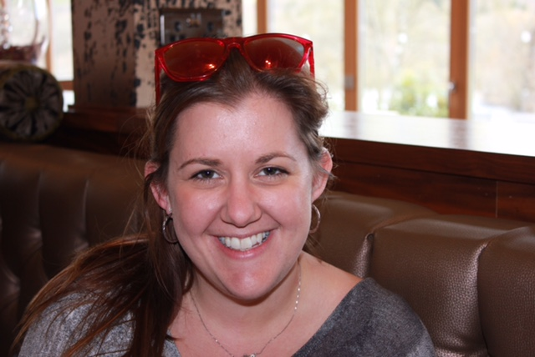**Gillian Redmond** graduated from Memorial University's Bachelor of Recreation program in 2011 and obtained the Certified Therapeutic Recreation Certification (CTRS) title from the National Council for Therapeutic Recreation Certification in May 2012. For the past 4 years she has been a Recreation Development Specialist with Eastern Health. Gillian has experience working in Rehabilitation, Long Term Care and most recently holds a position within the Mental Health and Addictions Program half time with the Geriatric Assessment Unit at the Waterford and the other half time at the Tuckamore Centre. She has been an active member of NLTRA and currently sits on the board. Gillian is looking forward to another great conference and year with NLTRA.

Executive Bio: central vp

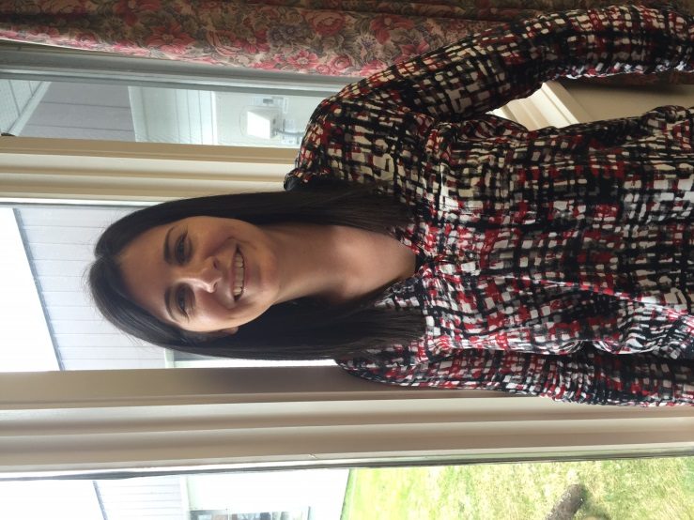**Olivia Organ** is a CTRS currently working at Valley Vista in Springdale as a Recreation Specialist II. She completed her diploma in Recreation Therapy from Keyin College in Grand Falls in 2003. She then proceeded to work for the Alzheimer’s society in Fort McMurray, AB for a while, and then went back to Memorial University where she graduated with a degree - Bachelor of Recreation. Olivia obtained the Certified Therapeutic Recreation Specialist (CTRS) title from the National Council for Therapeutic Recreation Certification in 2010. She worked in Alberta for 6 years in Long Term Care before she moved back to the rock in February 2015!

Olivia has been the NLTRA Central VP for one year and is finding the role very rewarding and exciting! Olivia is very passionate about the TR field and loves the work she does with seniors.

Executive Bio: western vp

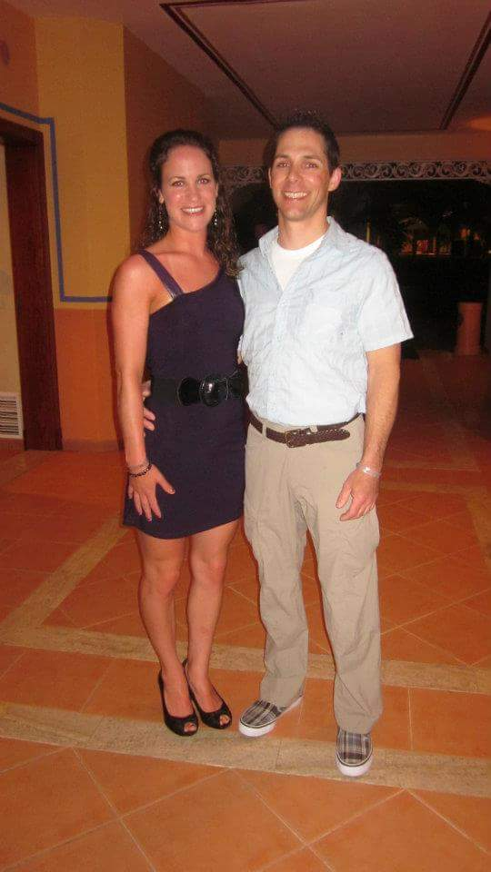**Elise Fisher** has been a Recreation Therapy Worker with Western Health since 2013, and currently works on the Alternate Level of Care units at Western Memorial Regional Hospital. Hailing from Nova Scotia originally, Elise and her husband have lived in Newfoundland for almost 7 years and settled in the beautiful Humber Valley 5 years ago. When not enjoying time with her patients, Elise loves hiking, canoeing, fishing, rock climbing, skiing, and all the other wonderful activities that the beautiful Western region has to offer. Elise got involved with the NLTRA as Student Rep while she completed her diploma through Academy Canada during the 2012/2013 term, and has really appreciated being Western VP for the past year and looks forward to the year ahead. She is currently enrolled to complete her degree in Therapeutic Recreation through the University of Lethbridge’s online program, and Elise hopes to continue being involved with the NLTRA and all the good work the association does.

Executive Bio: secretary

**Tara Power** completed her Bachelor's Degree in Recreation from Memorial University of Newfoundland. She is currently a Certified Therapeutic Recreation Specialist employed by Eastern Health at The Grace Centre; an adult alcohol and drug treatment centre. This is Tara's 2nd year sitting on the NLTRA executive and she has been involved with many past conferences. Tara is passionate about Therapeutic Recreation and strives for advancement in the TR Profession.

Executive Bio: treasurer

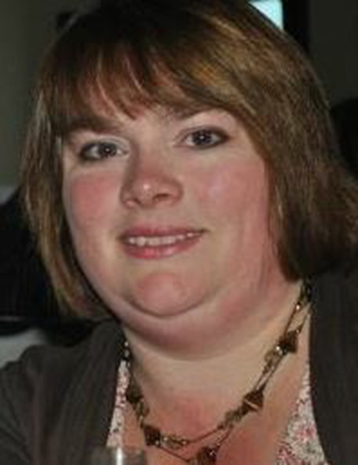**Penny O’Brien** has been employed with Eastern Health since June 2002 as a Recreation Therapy Worker II. She’s currently working at Saint Luke’s Homes in St. John’s where she loves working with the residents in long term care. Penny has been involved with the NLTRA for a number of years. In her spare time Penny enjoys camping, walking, a good book or spending time with family and friends.

Executive Bio: membership coordinator

**Laura McDonald** graduated from Dalhousie University with a Bachelor of Science (Recreation) in 2013 and attained the Certified Therapeutic Recreation Specialist (CTRS) title from the National Council for Therapeutic Recreation Certification as of May 2013. For the past three years I have worked at the Health Sciences Centre in St. John’s, NL as a Volunteer Coordinator. I have served on the NLTRA executive since 2014, and while I have enjoyed my time on the board I am looking forward to where the association is going over the next few years. I wish the new executive the best of luck in the future.

Executive Bio: website coordinator & support

**Danielle Bennett** is a CTRS currently working at St. Patrick’s Mercy Home long term care home. She’s been employed with Eastern Health since 2010, and works closely with the Recreation Therapy Workers and Music Therapist at this site planning and implementing programs based on the needs of the residents. Danielle is on the NLTRA planning committee, and is the coordinator for the website. This year she has also taken on the responsibility of Registration and Volunteer Coordinator for the Annual  NLTRA Conference.

Sponsors

**Thank you to our generous sponsors:**



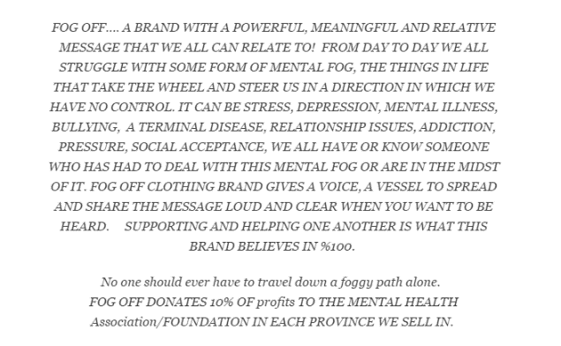

**Thank you to our Gold Sponsor:**